Concave Mirrors Worksheet
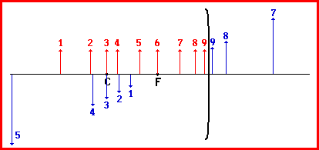
- Describe the four image characteristics according to the LOST method for each of the following 9 objects. (Note: the objects are located 1 through 9 left of the mirror, upright on the principal axis)
<----------- objects ----------->

Image | Location | Orientation | Size | Type
1

2

3

4

5

6

7

8

9

- Identify the means by which you can use a concave and/or a plane mirror to form a real image.

- Identify the means by which you can use a concave and/or a plane mirror to form a virtual image.

- Identify the means by which you can use a concave and/or a plane mirror to produce an upright image.

- Identify the means by which you can use a concave and/or a plane mirror to produce an inverted image.

- Are all real images larger than the object?

- Draw the image in the following diagrams and characterize the image using the LOST method.

