Converging & Diverging Lens Worksheet
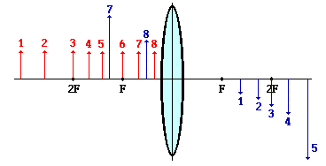
- Describe the four image characteristics according to the LOST method for each of the following 8 objects. (Note: the objects are located 1 through 8 in order, left of the lens, upright on the principal axis)
<--------- objects -------->
Image | Location | Orientation | Size | Type
1

2

3

4

5

6

7

8

- Identify the means by which you can use a converging and diverging lens to form a real image.

- Identify the means by which you can use a converging and diverging lens to form a virtual image.

- A converging lens is sometimes used as a magnifying glass. Explain how this works; specifically, identify the general region where the object must be placed in order to produce the magnified effect.

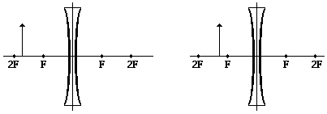
- Draw the image in the following diagrams and characterize the image using the LOST method.
- Draw the image in the following diagrams and characterize the image using the LOST method.

