Summative Evaluation - Climate Change Name: ___________________

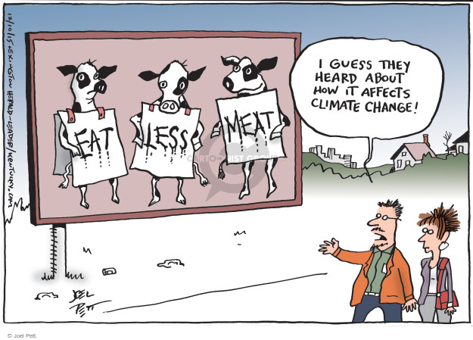
Throughout this unit, you have learned a lot about the negative impacts of climate change. Now is the time to act and find solutions.
In a group of 2, select either:
- A negative impact related to climate change, OR,
- A source of greenhouse gases (GHGs) from the following:

- Ocean acidification
- Pollution of plastics in the oceans
- The melting of glaciers
- Transmission of diseases
- Desertification
- Deforestation
- The loss of wetlands
- Increase of a Greenhouse Gas:
  - Methane
  - Carbon dioxide
  - Water vapour
  - Tropospheric Ozone
  - Nitrous oxide

Imagine that the class consists of a government panel that wants to invest in your solution. Present a UNIQUE and creative solution for the problem you have chosen. It must be in the form of a commercial pitch of 5 minutes (think Shark Tank or Dragon’s Den):

Examples:
https://twitter.com/kaoru_yokono/status/998715136008323072
https://www.youtube.com/watch?v=D22o4708WeU

Structure :
1. Description of the problem with the facts/research/statistics → 2 minutes
2. Description of your solution → 2 minutes
3. A conclusion (which makes us think and want to invest in your ideas → 1 minute

Thinking/Investigation | Communication
Description of the problem /2  Statistical evidence /2  Realistic and creative solution /5  Answers to questions /1  Total: /10 | Scientific language /2  Effective use of visuals /2  Clear, expressive and engaging voice /3  Structure and organization /2  Length of 5 min /1  Total: /10

Presentation date: _________________________

