What is Light?

Electromagnetic waves

- The bug moves up and down while the wave goes from left to right
- Similarly, a charged particle moves up and down while the electromagnetic wave goes from left to right
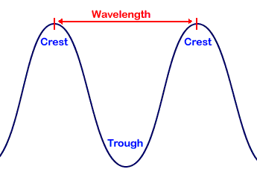
Wavelength

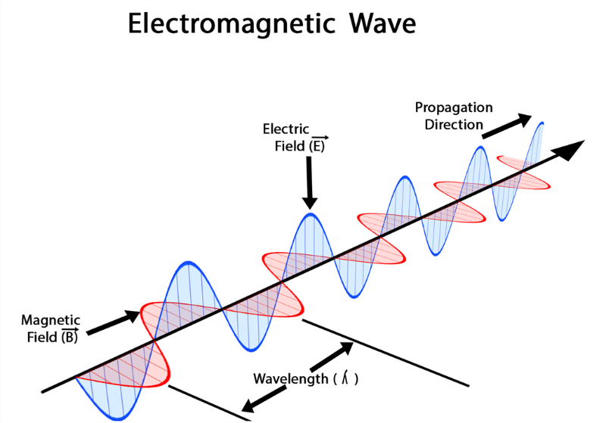

Electromagnetic spectrum

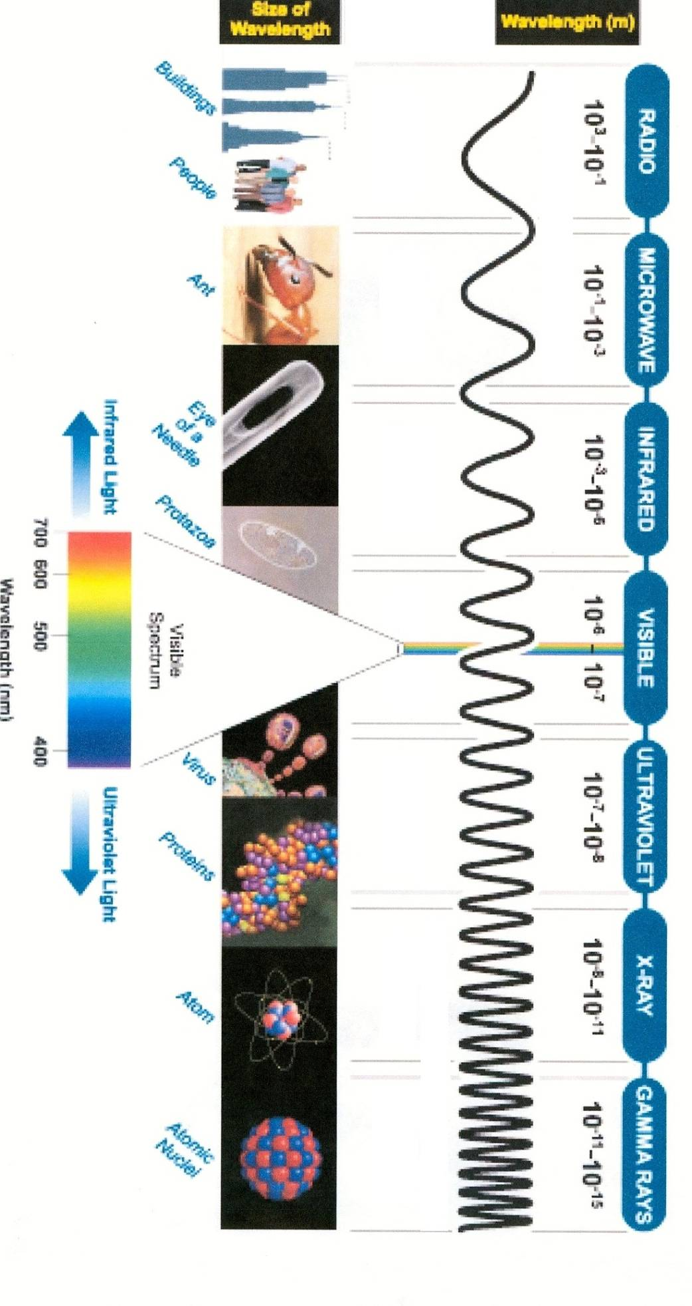

- Red light has the longest wavelength of visible light (7.0 x 10⁻⁷ m or 700 nanometers)
- Blue light has the shortest wavelength of visible light (4.0 x 10⁻⁷ m or 400 nanometers)

Using the electromagnetic spectrum, order the following waves from shortest (1) to longest (5) wavelength:
5 Radio waves
1 X-rays
3 Visible
4 Infrared
2 Ultraviolet

VIDEO: https://www.youtube.com/watch?v=cfXzwh3KadE

