How We See and Common Eye Problems

In the normal eye light focuses at the retina.
In bright light conditions the pupil contracts
In low light the pupil dialates

myopia or nearsightedness

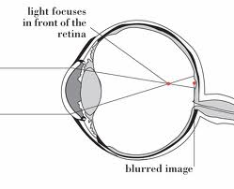
-Can see what is close up
-Objects at a distance appear blurry
-Light focuses before the retina

-Usually caused by weak ciliary body and muscles

hyperopia or farsightedness

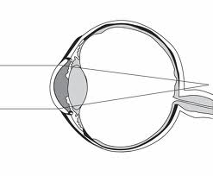
-Can see what is far away
-Objects that are close seem blurry
-Light focuses beyond the retina
-Usually caused by tightening of the ciliary body

Colour blindness: monochromy or dichromy
Caused by a poor development of the cones
More common in men than in women
Types of colour blindness: red green colour blindness dichomy & complete monochromy

Questions:
1. Conduct a vision test on yourself using both eyes. Do a second and third, each time covering a different eye. Was there a difference between eyes?
2. How can vision be corrected if both distant objects and close objects become blurry?
3. Surgery can be used to correct vision problems by reshaping the eye, suggest what part of the eye might be reshaped and why?
4. If colour blindness is linked with the cone cells, what might happen to a person that has a reduced number of rod cells?
5. Why is correcting your vision and getting your eyes checked regularly important?

