Greenhouse Effect

It is a _______________________ process that has been happening for hundreds of years.

Gases and clouds _________________ infrared __________________________ emitted from the

Earth's surface and radiate it, heating the atmosphere and Earth's surface.
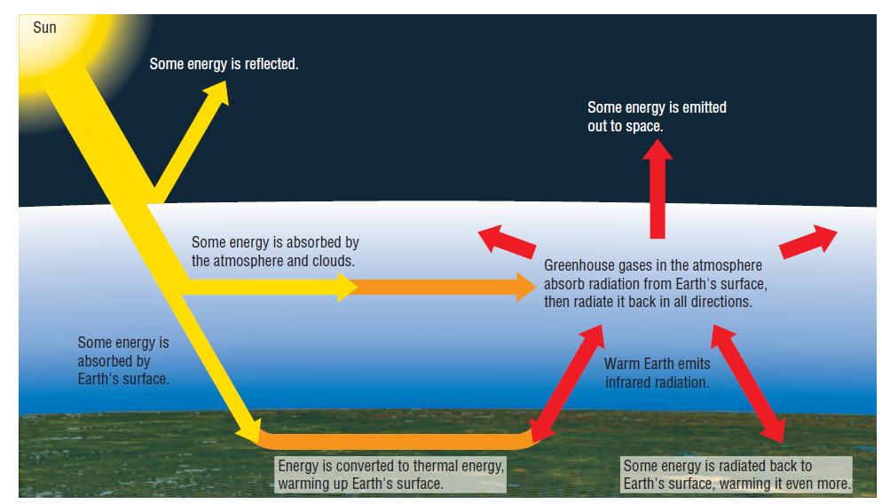

Greenhouse Gases - Any gas in the atmosphere (ie: water vapour, carbon dioxide, and

methane) that __________________ lower energy infrared radiation

GAS | CHEMICAL FORMULA/MOLECULAR STRUCTURE | NATURAL ABUNDANCE IN ATMOSPHERE (HIGH/LOW) | ABILITY TO ABSORB THERMAL ENERGY (HIGH/LOW) | CONTRIBUTION TO GREENHOUSE EFFECT  (HIGH/LOW)
Oxygen
Nitrogen
Carbon Dioxide
Water Vapour
Methane
Ozone
Nitrous Oxide

Positive Feedback Loops

Negative Feedback Loops

What would happen if the amount of these gases present in our atmosphere increased?

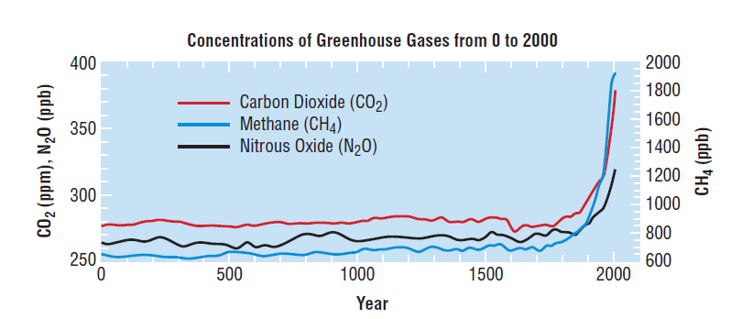
Anthropogenic -

GAS | ANTHROPOGENIC SOURCES:
Carbon Dioxide

Methane
Nitrous Oxide

CFCs (Chloroflouro carbons)

How does an increase in atmospheric CO₂, affect the global temperature?

Homework:
Read Section 8.2 and do pg 332 #2,3,6
Read Section 9.4 (pg: 384-389) Do questions #2, 5, 6

