How is heat transferred?
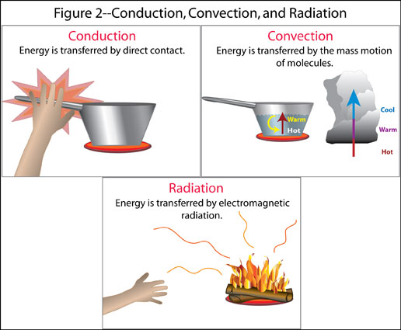
Thermal Energy Circulation

- The Sun’s radiation reaches Earth’s surface at different________________________

- Water and land absorb energy at________________ _________________
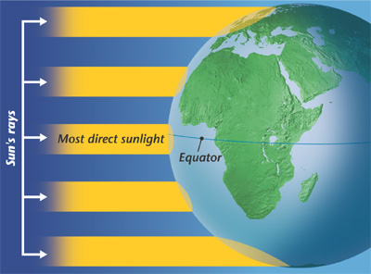
- Water absorbs ______________ thermal energy than air

- Thermal Energy is______________ from areas that receive _________

of radiation to areas that receive___________ radiation.

Which is more dense: Hot air or cold air? Hot water or cold water?

What does the uneven heating of air or water create? ____________________

- Convection Currents: A circular current in air and other fluids (water) caused by the

________________ of warm fluid as cold fluid ________________

Energy Transfer in the Atmosphere:
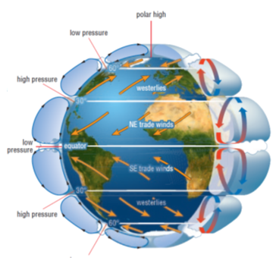
- As warm air rises, it creates an area of

_____________ pressure below it

- As cool air falls, it creates an area of

______________pressure

- Air flows from areas of high pressure

to areas of low pressure – this makes

air currents or ___________

Prevailing Winds - High and Low pressure, along with the rotation of the Earth causes winds that curve around the globe in the ______________________ almost all the time

Energy Transfer in the Ocean

- As water travels to the poles, it gets colder and saltier and therefore __________ dense

Thermohaline Circulation:

  - Dense water at the poles will ___________ to the ocean floor

  - Warmer surface water from the equator flows towards the poles to take its place

  - The continuous flow of water around the world’s oceans is driven by differences in water temperature and salinity

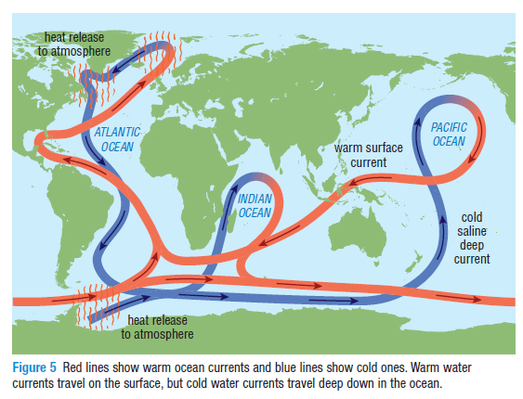

Ocean Currents and Climate Zones

- Warm ocean currents ________ the air above them which moves to the land and produces rain

- Cold ocean currents _________ the air above them causing cool, dry air to reach the land creating desert areas

