Impacts of Climate Change:

- Effects on ___________________ ________________ and our _________________

____________________that are caused by changes in climate, such as rises in Earth’s global temperature

The organization formed in 1988 in order to assess and evaluate the risks of human-caused climate

change is known as the ________________________________________________________________

____________________________________________________________________________________.

Some Impacts of Climate Change as Reported by the IPCC
Rising Sea Levels | Impacts on Agriculture
Impacts on Ecosystems | Impacts on Human, Animal & Plant Health
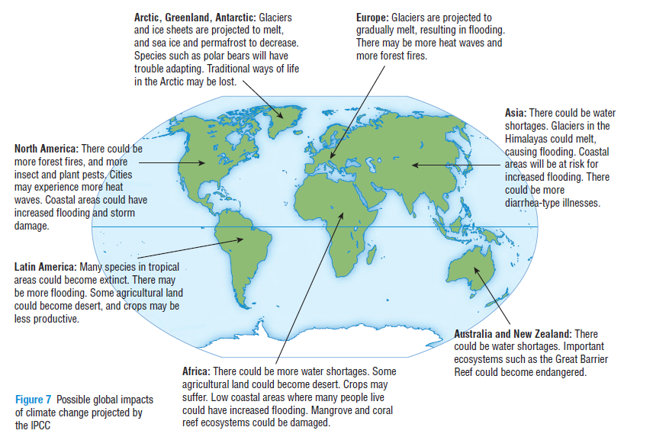
Continental Changes

Impacts in the Canadian Arctic

What is the impact of melting ice on polar bears?

How are sinkholes created?

Recall: What is the Albedo effect?

How do climate changes in the Arctic affect the rest of the world? Describe 5 different ways.

Impacts in Ontario:
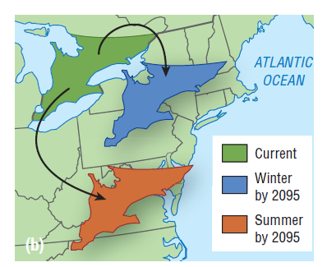

- Ontario’s average temperature could increase by_____________ degrees Celsius in the winter

and ____________ degrees Celsius in the summer

How will lake levels in Ontario be impacted? What are the impacts of this change?

As carbon dioxide concentrations and temperature increases, what will happen to the eco zones within Ontario?

Diseases and Illness:

- Increase in population of ________________________________________________ (ex: West Nile disease (mosquitoes); Lyme disease (deer ticks))

- Increase in ______________________________________________ (asthma etc)

Agriculture:

- Changes in growing season could be beneficial for soybean and corn farmers, but we could also

see growth of __________________________________________

- Crops that previously could not have been grown in Ontario, may be able to grow here

Forests:

- Hotter, drier summers will lead to more___________________________________________

- Increase in ______________________________________ will destroy forests

- As forests become less healthy, they will become a ____________________________________

instead of a _________________________________.

Electricity Use:

- As summers get hotter, we will use more electricity for air-conditioning which will produce even

more _______________________________________________

- In the winter, energy use may decrease

- In Ontario, about ¼ of our electricity is produced using ______________________________

power which does not produce greenhouse gas, but an increase in electricity usage will lead to

more _______________________________

Homework: Read Pg. 412-417 answer questions #2, 5
Read pg. 419-422 answer questions #1, 6

