UNFCCC
- The United Nations Framework Convention on Climate Change (UNFCCC) is an agreement by 192 countries to act to stabilize _________________ __________________
- created in 1992, it enables representatives from different countries to meet to discuss scientific and political action
- Each year, the nations meet to discuss ______________ ____________ ___________. These meetings are called ________ (Conference of the Parties)
- The nations that signed the UNFCCC agreed not to hinder food production or economic interests of other countries as well as to support sustainable development within their own countries

Kyoto Protocol:
- COP 3 held in 1997 in Kyoto, Japan
- Kyoto protocol is a plan within the UN, requiring industrialized nations to ___________ their GHG emissions by _____% by 2012
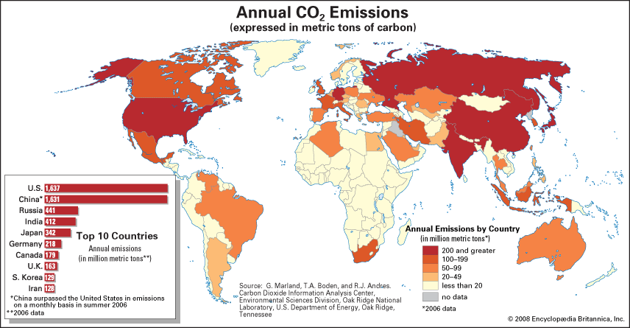
- a UNFCCC agreement originally signed by 161 countries to curb greenhouse gas emissions to 5% below 1990 levels by 2012
- It went into effect in 2005, as of 2008, 183 countries had ____________________it. It outlined a framework in which each country was assigned a target greenhouse gas reduction
- USA never ratified the Kyoto protocol
- Canada ratified in 2002
Common but differentiated responsibilities:
- Developed countries (US,UK, Canada) have already polluted the atmosphere with greenhouse gases (GHGs) through _______________________. So they’re the one who created/started global warming and all the mess.
- While Developing countries (India and Brazil) have started polluting the world only recently.
- Therefore, the developing countries such as India, Brazil should _____________ ___________ of the burden of lowering overall emissions.
- Developed countries (US,UK) should bear _______________responsibility in fixing global warming because they’re the one more responsible for it.
- So, while it is the “Common” responsibility of every nation of this world to ________________ Green House Gas emission, there should be some difference between the responsibility given to developed countries and developing countries.
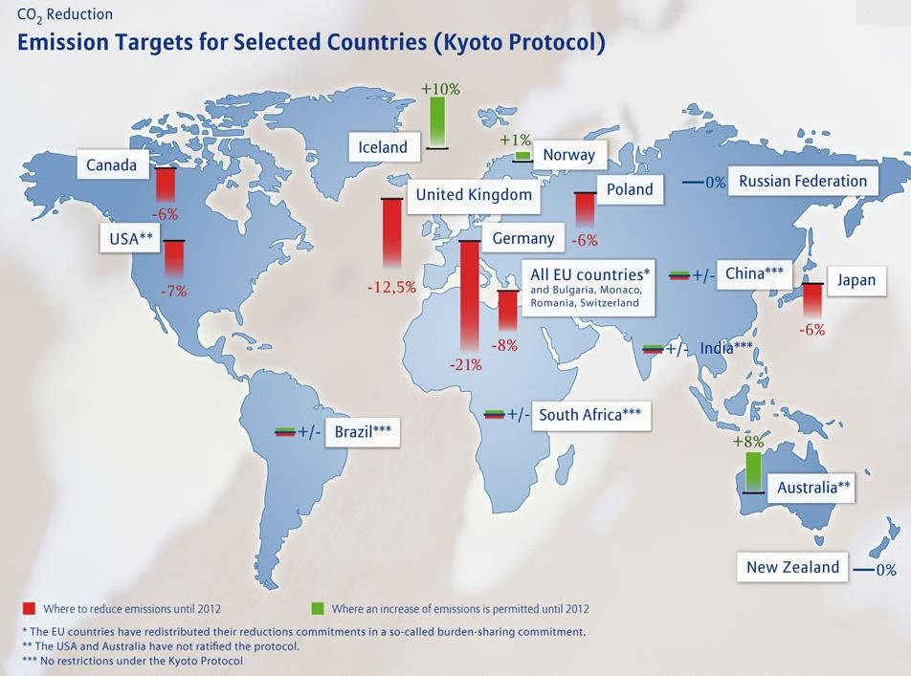
- Kyoto Protocol follows that principle and assigns separate responsibilities to the countries.
- Developed countries agreed to higher targets than developing countries
  - Developed nations (USA,UK), will compulsorily reduce their green house gas (GHG) emission by ______.
  - Emission targets were set based on the level of pollution created by each developed nation
  - Developing nations like Brazil, South Africa, India and China, should reduce GHG emission but not compulsory.
As an incentive to follow through with the targets outlined in the Kyoto Protocol, countries were offered ______________ _______________ ______________ for the following:
- Helping a developing country reduce its emissions
- Helping a developed country reduce its emissions during a temporary economic problem
- Engaging in practices that help to _____________ ________ from the atmosphere (eg: planting trees)

Carbon Credits
- Each country is given an _______________ _____________ _______ (1Kyoto Unit = 1 carbon credit = 1 metric tonne of CO2 emitted)
- Countries are expected _________ to emit more than their quota
- However, if you need more carbon credits, you can ______________ them from other countries who haven’t reached their quota
- If you are big polluter, you can purchase carbon offset credits
- Those who buy __________________ are essentially investing in other projects that reduce emissions on their behalf, either because they are unable to do so themselves or because it is ________ _________________ to make their own reductions.
- One thing to note is that not all carbon offsets are ___________ ___________. Because the market is new and largely ____________________, some offsets are unlikely to have any benefit for the climate. This is one reason why carbon offsets have gotten a bad rap.
- Good offsets should be permanent and actually reduce GHG emissions that would have otherwise not been reduced without this offset

Canada & Kyoto:
Canada agreed to reduce its greenhouse gas emissions to _____% below the 1990 level
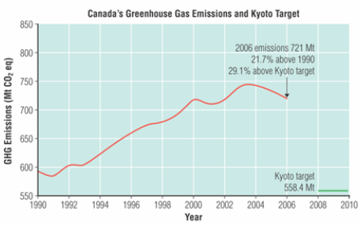
- Between 1990 and 2006, Canada’s greenhouse gas emissions increased by 22%
- One reason that we can not make our Kyoto commitment is due to development of the ______________ ______ _________.
- The U.S.A. signed the Kyoto Protocol but never ratified it

In 2011, Canada ___________________ from the Kyoto Protocol!!

Copenhagen Accord
- The Copenhagen Agreement took effect in ______ after Kyoto expired
- Not legally binding
- Countries ____________________ made emission pledges
- Canada’s commitment is to cut emissions _____% below 2005 levels by 2020

What can we do?
- Reduce your emissions
- Try to achieve carbon neutrality by purchasing certified, good carbon offset credits http://www.davidsuzuki.org/publications/resources/2009/purchasing-carbon-offsets/
- http://www.davidsuzuki.org/what-you-can-do/queen-of-green/videos/
- Be an environmental steward

HOMEWORK: Read pg. 423-428 #2, 3, 4, 5 Read pg. 429-433 #1, 2, 5, 6, 7, 10

