Animal Tissues Table
Tissue Type | Description of function(s) | Micrograph | Examples
Epithelial |  | 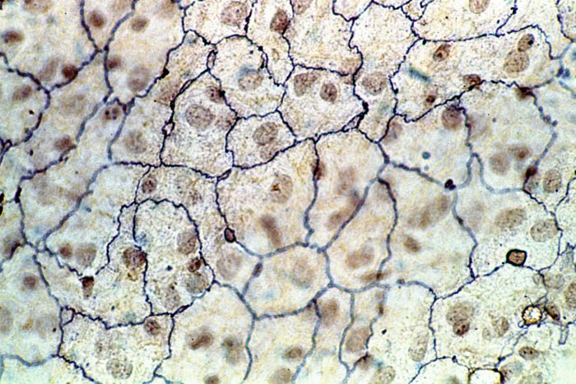  Squamous epithelial tissue
Connective |  | Bone tissue  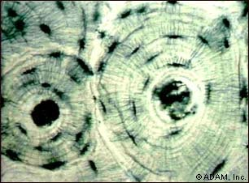
Muscle |  | Smooth muscle tissue
Nervous |  | Neuron Cell  