Converging & Diverging Lens Ray Diagrams

The following diagram illustrating the path of light from an object through a lens to an eye placed at various locations was shown. In this diagram, five incident rays are drawn along with their corresponding refracted rays. Each ray intersects at the image location and then travels to the eye of an observer. Every observer would observe the same image location and every light ray would follow the Snell's Law of refraction. Yet only two of these rays would be needed to determine the image location since it only requires two rays to find the intersection point. Of the five incident rays drawn, three of them correspond to the incident rays described by our three rules of refraction for converging lenses. We will use these three rays through the remainder of this lesson, merely because they are the easiest rays to draw. Certainly two rays would be all that is necessary; yet the third ray will provide a check of the accuracy of our process.
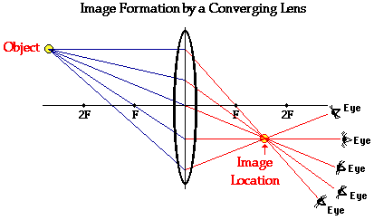
Step-by-Step Method for Drawing Ray Diagrams
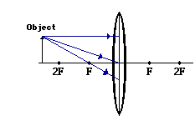
1. Pick a point on the top of the object and draw three incident rays traveling towards the lens.
Using a straight edge, accurately draw one ray so that it passes exactly through the focal point on the way to the lens. Draw the second ray such that it travels exactly parallel to the principal axis. Draw the third incident ray such that it travels directly to the exact center of the lens. Place arrowheads upon the rays to indicate their direction of travel.
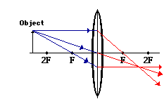
2. Once these incident rays strike the lens, refract them according to the three rules of refraction for converging lenses.
The ray that passes through the focal point on the way to the lens will refract and travel parallel to the principal axis. Use a straight edge to accurately draw its path. The ray which traveled parallel to the principal axis on the way to the lens will refract and travel through the focal point. And the ray which traveled to the exact center of the lens will continue in the same direction. Place arrowheads upon the rays to indicate their direction of travel. Extend the rays past their point of intersection.

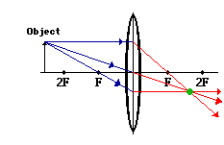
3. Mark the image of the top of the object.
The image point of the top of the object is the point where the three refracted rays intersect. All three rays should intersect at exactly the same point. This point is merely the point where all light from the top of the object would intersect upon refracting through the lens. Of course, the rest of the object has an image as well and it can be found by applying the same three steps to another chosen point. (See note below.)
4. Repeat the process for the bottom of the object.
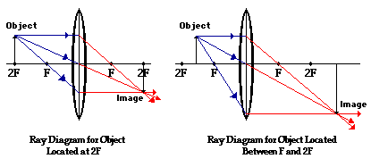
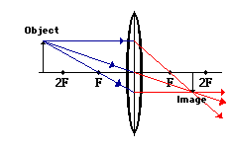
One goal of a ray diagram is to determine the location, size, orientation, and type of image which is formed by the double convex lens. Typically, this requires determining where the image of the upper and lower extreme of the object is located and then tracing the entire image. After completing the first three steps, only the image location of the top extreme of the object has been found. Thus, the process must be repeated for the point on the bottom of the object. If the bottom of the object lies upon the principal axis (as it does in this example), then the image of this point will also lie upon the principal axis and be the same distance from the mirror as the image of the top of the object. At this point the entire image can be filled in.

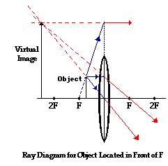
It should be noted that the process of constructing a ray diagram is the same regardless of where the object is located. While the result of the ray diagram (image location, size, orientation, and type) is different, the same three rays are always drawn. The three rules of refraction are applied in order to determine the location where all refracted rays appear to diverge from (which for real images, is also the location where the refracted rays intersect).
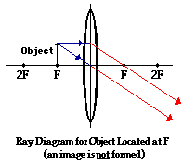
The image location can be found by tracing all light rays backwards after they have been refracted until they intersect. A virtual image is formed if the object is located less than one focal length from the converging lens.

For the case of the object located at the focal point (F), the light rays neither converge nor diverge after refracting through the lens. Subsequently, the light rays will not converge to form a real image; nor can they be extended backwards on the opposite side of the lens to intersect to form a virtual image. So how should the results of the ray diagram be interpreted? The answer: there is no image!!

Step-by-Step Method for Drawing Ray Diagrams
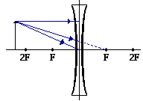
1. Pick a point on the top of the object and draw three incident rays traveling towards the lens.
Using a straight edge, accurately draw one ray so that it travels towards the focal point on the opposite side of the lens; this ray will strike the lens before reaching the focal point; stop the ray at the point of incidence with the lens. Draw the second ray such that it travels exactly parallel to the principal axis. Draw the third ray to the exact center of the lens. Place arrowheads upon the rays to indicate their direction of travel.
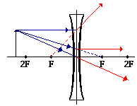
2. Once these incident rays strike the lens, refract them according to the three rules of refraction for double concave lenses.
The ray that travels towards the focal point will refract through the lens and travel parallel to the principal axis. Use a straight edge to accurately draw its path. The ray which traveled parallel to the principal axis on the way to the lens will refract and travel in a direction such that its extension passes through the focal point on the object's side of the lens. Align a straight edge with the point of incidence and the focal point, and draw the second refracted ray. The ray which traveled to the exact center of the lens will continue to travel in the same direction. Place arrowheads upon the rays to indicate their direction of travel. The three rays should be diverging upon refraction.
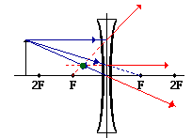
3. Locate and mark the image of the top of the object.
The image point of the top of the object is the point where the three refracted rays intersect. Since the three refracted rays are diverging, they must be extended behind the lens in order to intersect. Using a straight edge, extend each of the rays using dashed lines. Draw the extensions until they intersect. All three extensions should intersect at the same location. The point of intersection is the image point of the top of the object. The three refracted rays would appear to diverge from this point. This is merely the point where all light from the top of the object would appear to diverge from after refracting through the double concave lens. Of course, the rest of the object has an image as well and it can be found by applying the same three steps to another chosen point. See note below.
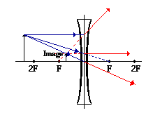
4. Repeat the process for the bottom of the object.
The goal of a ray diagram is to determine the location, size, orientation, and type of image which is formed by the double concave lens. Typically, this requires determining where the image of the upper and lower extreme of the object is located and then tracing the entire image. After completing the first three steps, only the image location of the top extreme of the object has been found. Thus, the process must be repeated for the point on the bottom of the object. If the bottom of the object lies upon the principal axis (as it does in this example), then the image of this point will also lie upon the principal axis and be the same distance from the lens as the image of the top of the object. At this point the complete image can be filled in.

