Plant Organ Diagrams
Root Cross Section | Stem Cross Section
 | 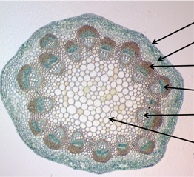
Leaf Cross section | Angiosperm Flower
 | 