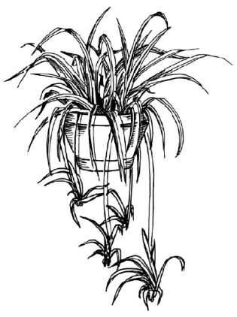
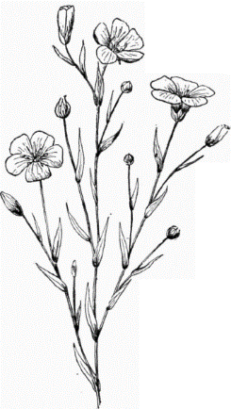
Plant Tissues Types
Tissue |  |  | Function
Epidermis
Cortex
Ground Tissue – Any tissue that is not Dermal of Vascular | Parenchymal Tissue
 | Collenchymal Tissue
 | Sclerenchymal Tissue
 | Chlorenchymal Tissue
Endodermis
Fiber Caps
Pith
Pallisade Mesophyll
Spongy Mesophyll
Xylem
Phloem
Stamen – The Male sex organ of the flower |  | Anther
 |  | Filament
Pistil – The Female Sex Organ of the flower |  | Stigma
 |  | Style
 |  | Ovary
 |  | Ovule

