Plant Tissues Table
Tissue Type | Description of function(s) | Micrograph | Examples
Meriste-matic |  | Apical meristem tissue  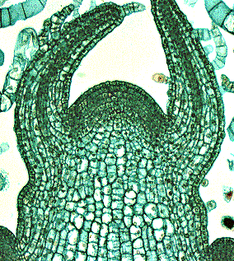
Epidermal |  | Leaf epidermal tissue  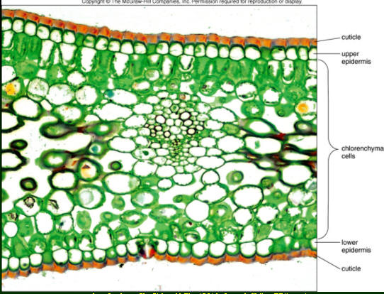
Ground |  | Stem ground tissue  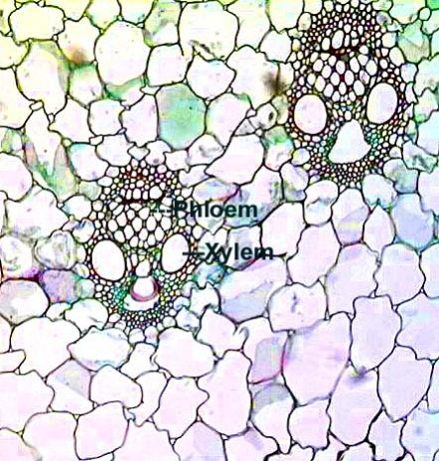
Vascular |  | Dicot root vascular tissue  